关于GPS模块获取到的经纬度不准，误差较大的问题该如何解决，以下是解决的方法。
- 首先观察GPS模组的定位数据，举例如下：
$GNGGA,101847.000,4001.54704,N,11618.37631,E,1,18,1.1,90.3,M,-9.8,M,,*6E
$GNGLL,4001.54704,N,11618.37631,E,101847.000,A,A*44
$GNGSA,A,3,05,06,07,11,13,21,195,199,,,,,1.7,1.1,1.3,1*3C
$GNGSA,A,3,03,07,08,10,13,19,20,29,38,40,,,1.7,1.1,1.3,4*31
$GPGSV,4,1,14,04,,,25,05,63,285,39,06,22,107,39,07,11,070,22,0*59
$GPGSV,4,2,14,11,62,085,45,13,34,175,29,15,,,33,17,,,26,0*65
$GPGSV,4,3,14,21,72,017,43,25,,,26,29,,,21,30,11,103,25,0*6D
$GPGSV,4,4,14,195,63,107,43,199,42,164,35,0*6B
$BDGSV,3,1,12,03,44,189,43,04,,,33,07,50,194,47,08,64,276,37,0*45
$BDGSV,3,2,12,10,56,214,33,13,54,263,39,19,22,221,27,20,71,214,47,0*71
$BDGSV,3,3,12,29,67,301,39,38,74,306,42,40,48,173,52,59,,,35,0*4E
$GNRMC,101847.000,A,4001.54704,N,11618.37631,E,0.00,0.00,260326,,,A,V*0A
$GNVTG,0.00,T,,M,0.00,N,0.00,K,A*23
$GNZDA,101847.000,26,03,2026,00,00*42
$GPTXT,01,01,01,ANTENNA OK*35
$GNGGA,101848.000,4001.54699,N,11618.37633,E,1,17,1.3,90.4,M,-9.8,M,,*6C
$GNGLL,4001.54699,N,11618.37633,E,101848.000,A,A*4C
$GNGSA,A,3,05,06,11,13,21,195,199,,,,,,2.3,1.3,1.9,1*34
$GNGSA,A,3,03,07,08,10,13,19,20,29,38,40,,,2.3,1.3,1.9,4*3E
$GPGSV,4,1,14,04,,,25,05,63,285,38,06,22,107,39,07,11,070,22,0*58
$GPGSV,4,2,14,11,62,085,45,13,34,175,29,15,,,33,17,,,26,0*65
$GPGSV,4,3,14,21,72,017,43,25,,,27,29,,,21,30,11,103,25,0*6C
$GPGSV,4,4,14,195,63,107,43,199,42,164,35,0*6B
$BDGSV,3,1,12,03,44,189,43,04,,,33,07,50,194,47,08,64,276,36,0*44
$BDGSV,3,2,12,10,56,214,33,13,54,263,39,19,22,221,27,20,71,214,47,0*71
$BDGSV,3,3,12,29,67,301,41,38,74,306,42,40,48,173,52,59,,,35,0*41
$GNRMC,101848.000,A,4001.54699,N,11618.37633,E,0.00,0.00,260326,,,A,V*02
$GNVTG,0.00,T,,M,0.00,N,0.00,K,A*23
$GNZDA,101848.000,26,03,2026,00,00*4D
$GPTXT,01,01,01,ANTENNA OK*35
$GNGGA,101849.000,4001.54695,N,11618.37635,E,1,17,1.3,90.4,M,-9.8,M,,*67
$GNGLL,4001.54695,N,11618.37635,E,101849.000,A,A*47
$GNGSA,A,3,05,06,11,13,21,195,199,,,,,,2.3,1.3,1.9,1*34
$GNGSA,A,3,03,07,08,10,13,19,20,29,38,40,,,2.3,1.3,1.9,4*3E
$GPGSV,4,1,14,04,,,25,05,63,285,38,06,22,107,38,07,11,070,22,0*59
...
从以上的GPS模组输出的原始数据来看，观察GNRMC语句可以获得原始的GPS定位数据，具体语句解析可以参考文档，这里不展开说明，以下是从语句输出的其中一个数据，如下：
$GNRMC,101848.000,A,4001.54699,N,11618.37633,E,0.00,0.00,260326,,,A,V*02
其中A表示定位成功，4001.54699表示纬度，前 2 字符表示度，后面的字符表示分；
N表示纬度方向：N-北，S-南；11618.37633表示经度，前 3字符表示度，后面的字符表示分；E表示经度方向：E-东，W-西
简单说明
原始格式：4001.54699,N → 北纬 40°1.54699′
原始格式：11618.37633,E → 东经 116°18.37633′
换算公式：十进制度数 = 度数 + 分数 ÷ 60
通过公式计算
- 北纬 4001.54699
拆分：
度 = 40，分 = 1.54699
40+601.54699​=40.025783°
- 东经 11618.37633
拆分：
度 = 116，分 = 18.37633
116+6018.37633​=116.306272°
最终结果
北纬：40.025783°
东经：116.306272°

在获取到经纬度信息后，通过网址计算每个坐标系的参数，网址链接：https://tool.lu/coordinate/
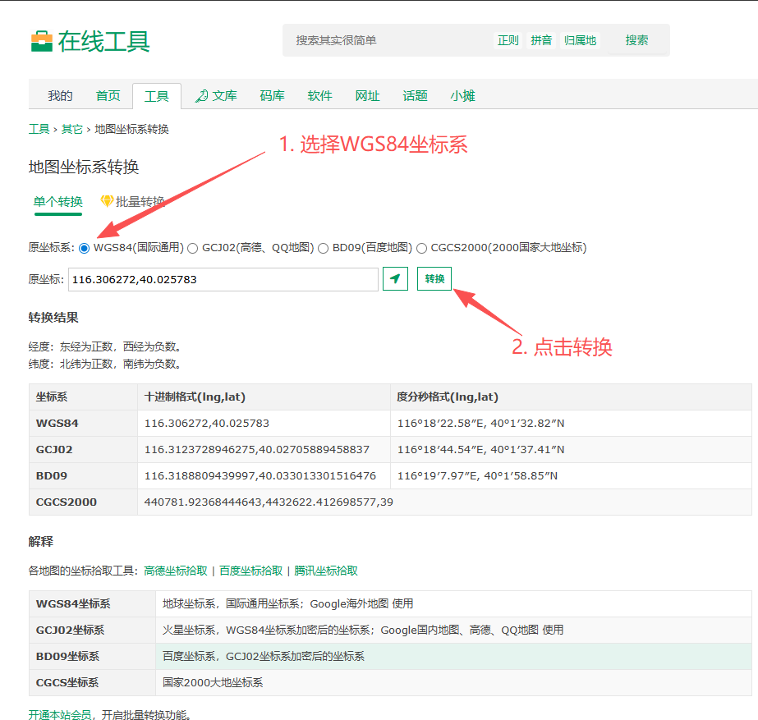
经过转换后可以查看到其他几个坐标系的参数值，再将坐标系参数值填写到经纬度查询定位网站上，网站链接：https://www.mapchaxun.cn/jingweiduchaxun
选择GCJ02坐标系的数值，截图如下：
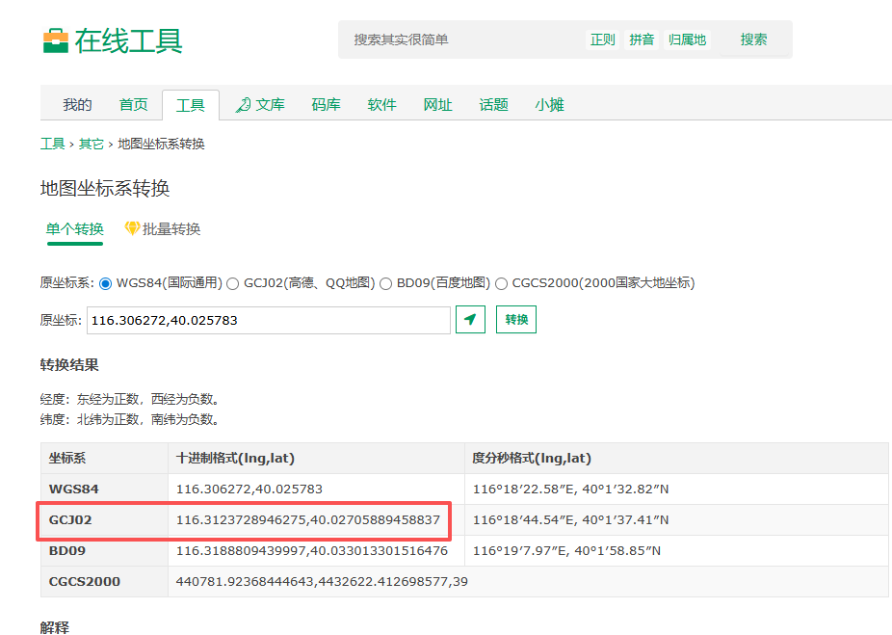

选择好参数后打开经纬线地图查询网址，参考图片上的配置即可在地图上找到对应的位置：
